Northwest Bible Church – Aug. 28, 2016 – Worship Service – Alan Conner
Christ in the O.T.
Abuses of the O.T.

Intro
Review Lk. 24:25-27, 44-47.

A. ABUSES OF THE O.T.

1. Avoidance.

2. Discontinuity.

3. Background only.

4. Mystical.

5. Moralism.

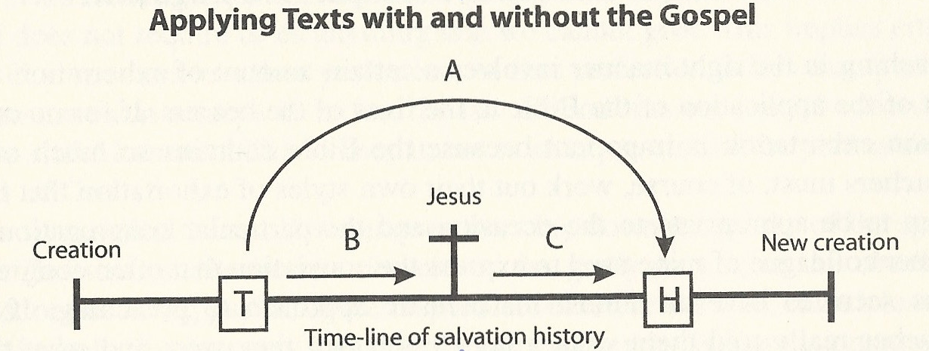
Graeme Goldsworthy, “Preaching the Whole Bible as Christian Scripture,” p. 117.

6. Allegorical.

a) Self-focus.

b) Christ-focus.

B. A BETTER APPROACH

1) Study the passage in its original literary and historical context.

2) Consider how this passage fits in with the flow of redemptive history

3) Now we can consider the personal application to our life.

